Instruction for e-mail service users

Access to mailbox can be realized through any browser including Internet Explorer, Mozilla Firefox, Apple Safari, Chrome, and other web browsers working under Unix, Apple Macintosh or Microsoft Windows operating systems control.

To use the e-mail service you need to make the following steps:
- Input http://mail.university.ks.ua into web browser’s address line and go on the website page.

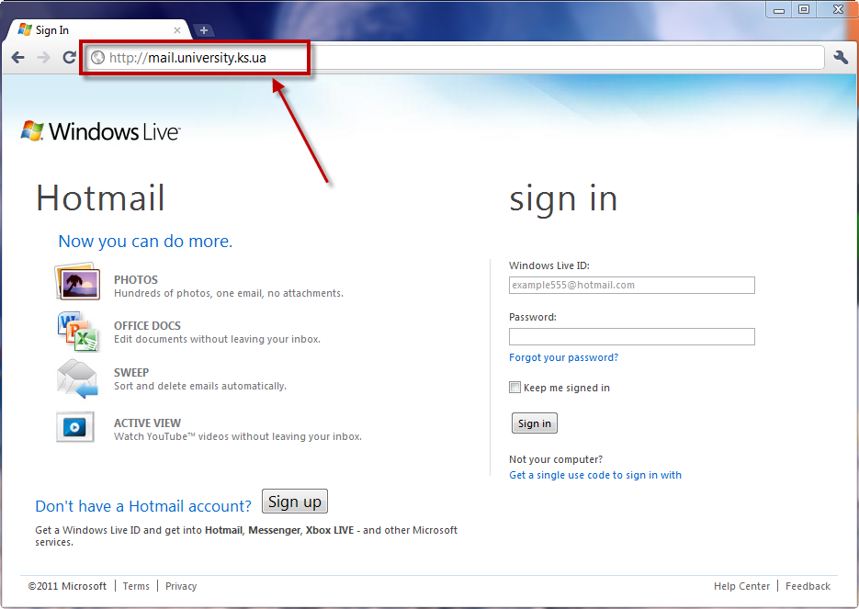
Picture 1
- You should fill in your account data in the right side of the page under the inscription “Sign in” as it is shown in picture 2 (given e-mail address and password). For example:

ivanov.ivan@university.ks.ua

123456

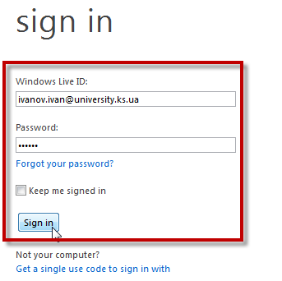
Picture 2
- After pressing “Sign in” button, you should enter information data about your account and change the password on a new one following the instructions (pic. 3). Read attentively conditions of service and confidentiality declaration (agreement). After that press the button “I accept” in the bottom of the page.

Note! Keep in mind new password. Only you should know it!!!
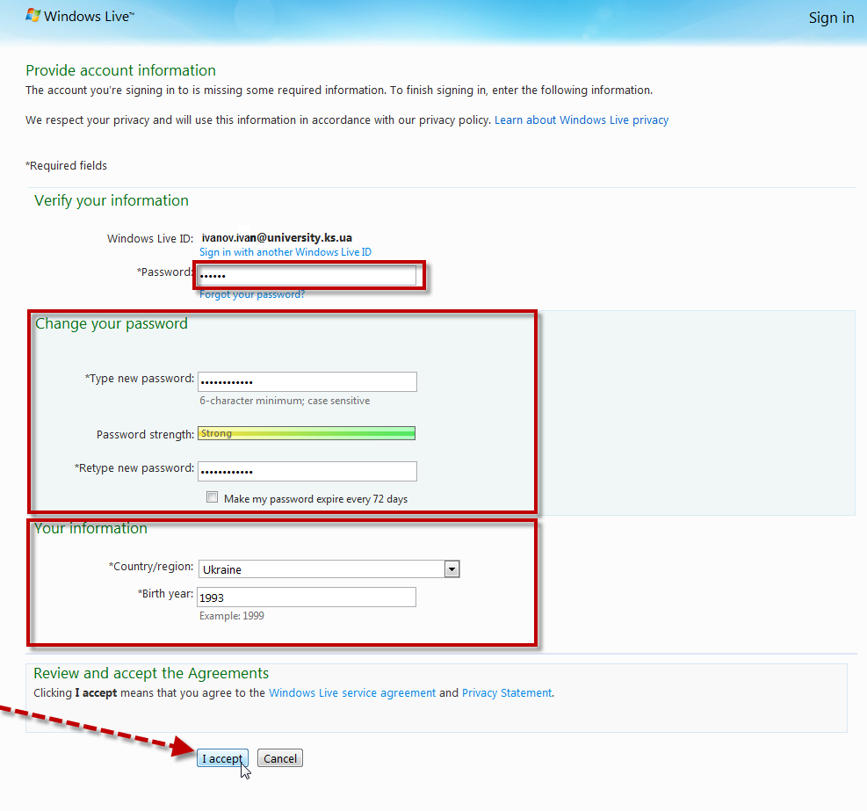
Picture 3
4) If after pressing the button there appears a message (pic. 4) you should press the button “Sign in to Windows Live” and introduce year and country of birth data in a new page. Then press the button “I accept” (pic. 5).
If it is not appears then go to the 5 item.

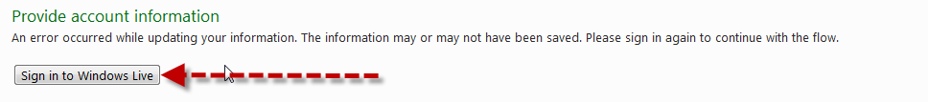
Picture 4
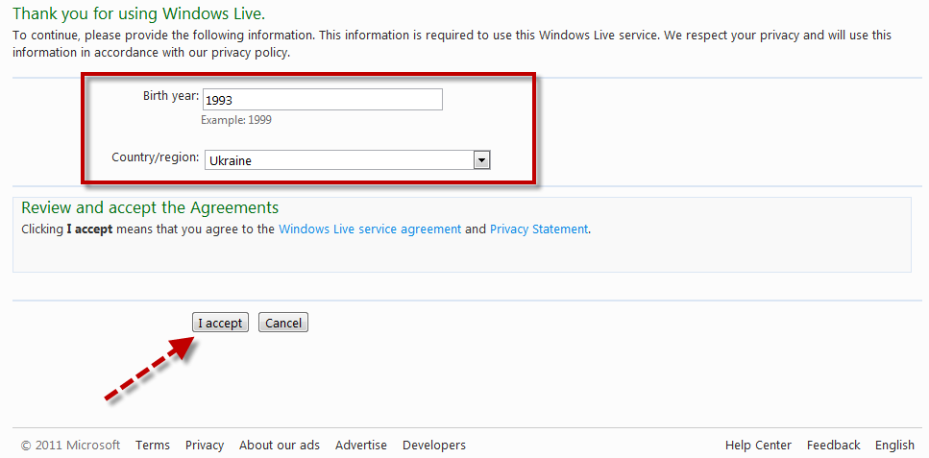
Picture 5
5) You will see the dialog box, where you should chose the language and time zone (pic. 6). After completing, press the button “Ok”.

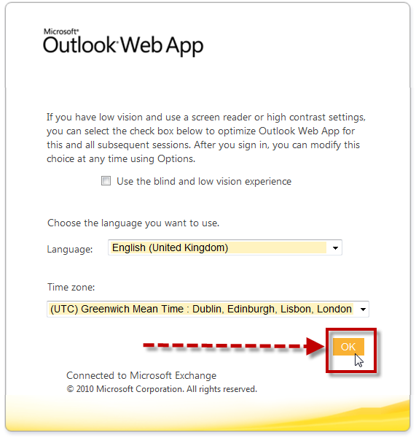
Picture 6
6) After that you will find yourself in your own mailbox (pic. 7). From this point on you’ll be able to use it at your convenience. If you need help, press the button in the right top corner and follow instructions the service provides (pic. 8). If you want to quit, press the “sign out” button in the right top corner of the page.
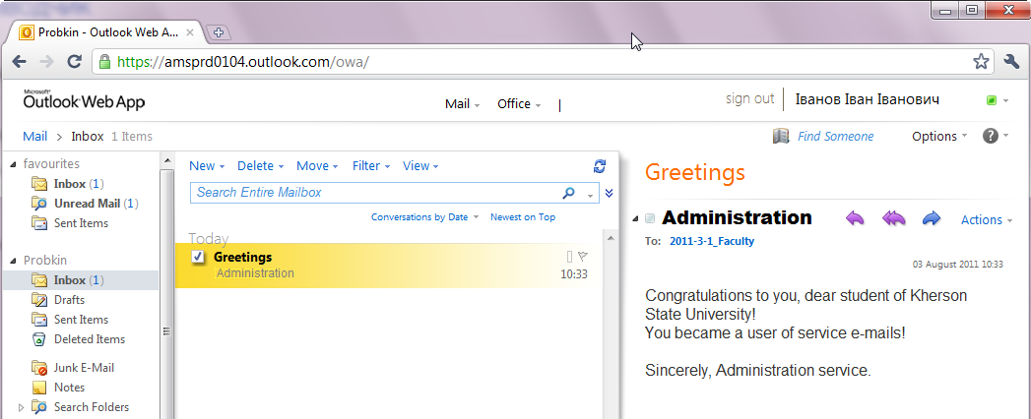
Picture 7
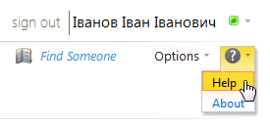
Picture 8
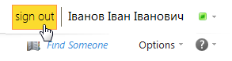
Picture 9

To receive more detailed information for service use, account password change in case of its loss or technical failure consult the KSU Department of Integrated Learning Environments.
Tel.: (0552) 32-67-82
Internal phone: 602
Office: 515
Alferov Eugene: alferov_jk@ksu.ks.ua
Maksimovich Marina: maxmar1@ksu.ks.ua

